UNIT 2: Cells Guide
Unit 2 Vocabulary:
Word | Parts/meaning of word, if any | Definition | Picture example if any
Eukaryotic cell | Eukaryotic  Eu=  Kary=
Prokaryotic cell | Prokaryotic  Pro=  Kary=
Organelles

Diffusion

Osmosis

Cell Cycle

Chromosomes
DNA/RNA

OLS Lesson 1: The Cell
- Students will discover how the cell exhibits the characteristics of living organisms: growing, reproducing, obtaining and using energy, adapting to the environment. Further instruction will lead students to compare and contrast cell types.
Essential Questions | Main Concepts
Words to know:  Cytoplasm  Nucleus  How is the cell the basic unit of structure and function in all living things?  What events helped the ‘cell theory’ develop over time?  How do cells arise from pre-existing cells?  How do the parts of a cell function for the cell to live, grow, and reproduce? | The cell is the most basic structure that exhibits the characteristics of life and meets the challenges of life.  A cell grows, divides (reproduction), has homeostasis, metabolism, passes on genetic info, and responds to stimuli.  Scientific Theory:  A theory is _________________________________________________.  Microscope invented in 1600’s allowed scientists to begin to examine and describe cells  Cell Theory: (See timeline in OLS)  Parts of a Cell:  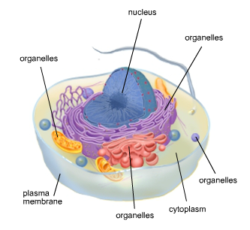  Nucleus- contains the genetic information  Cytoplasm- surrounds the nucleus and contains organelles  Organelles- perform the different functions the cell needs to meet the challenges of life  Plasma membrane- surrounds the cell and separates its contents from the outside world.
Essential Questions  OLS Lesson 2: Differing Cells Students will define and describe prokaryotic and eukaryotic cells. | Main Concepts
Words to know:  Cilia  Flagella  Pili  Plasma membrane  Plasmid  Ribosome  How do prokaryotic and eukaryotic cells differ?  Give examples of prokaryotic cells and eukaryotic cells  How do cells move around their environment? | - Prokaryotic cells are ____________________________  - ____________________________ or other membrane-enclosed structures.  - Prokaryotic cells are surrounded by a_____________ __________ and some have _____ _______ _ _____________.  - Pili (hairs:) for __________ and  - Flagella (whiplike structures)for _______________  - ____________ is an example of a prokaryotic cell  - Has genetic material in the region of the cytoplasm called the __________ and also structures called ________________.  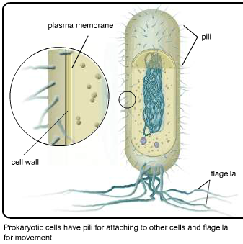  - Eukaryotes are larger, more complex cells  - Can be single-celled or multicellular organisms  _________ and ___________ cells are examples of eukaryotic cells  - Contains a __________, where the genetic material is found  - May have cilia or flagella to help move around  - Eukaryotes contain membrane bound organelles  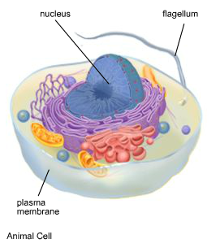

OLS Lesson 3: Cell Organelles
Essential Questions | Main Concepts
Words to know:  Cytoskeleton  Endomembrane system  How do the structures within the cell help the cell to function and meet the challenges of life?  Nucleus: The brain of the cell (contains genetic info for cell)  Nuclear membrane: double layered membrane surrounding nucleus  Cytoplasm: Jelly like substance that cushions organelles and keeps them in place.  Endomembrane system: Includes nuclear membrane and network of membranes in cell, transports materials around the cell. Produces, Sorts and Packages.  Mitochondria: Power plants of cells, cellular respiration (energy conversion) takes place here  Ribosomes: protein factories of cells  Flagella: Helps cells move through fluid  Cytoskeleton: “Cell skeleton” – system of fibers and tubes that gives the cell structure and support  Plasma membrane: Gate keeper of cell  Cell wall: Found in plant cells – provides extra support and structure  Chloroplast: Found in plant cells. Convert sunlight into energy-this process is photosynthesis.  Good review!  Cells, cells, they’re made of Organelles!  http://www.youtube.com/watch?v=-zafJKbMPA8 | The structures within a cell that perform specific functions are known as ______________.  What is the purpose of these organelles in the cell? _______________________________________________________________  The genetic material of a prokaryotic cell is found in the ____________ and the genetic material of a eukaryotic cell is found in the _____________.  The _________________are the power plants of the cell, converting sugar and other fuels into a form of energy the cell can use.  Eukaryotic cells have membrane-bound __________________.  ______________________, the protein-assembly factories of the cell, are present in prokaryotic cells, animal cells, and plant cells.  In plant cells, conversion of light energy into chemical energy occurs in the ______________________.  Cells can move around using one or more long _________________ or many shorter __________________.  Materials are transported around the cell by the ___________________  ________________.  Both prokaryotic and eukaryotic cells have a ________ ___________ that surrounds their ______________________.  The ________________ gives shape, structure and support to a cell.  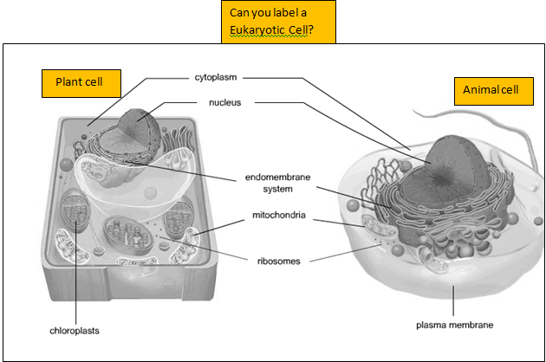

OLS Lesson 6: DNA to RNA to Proteins
Students will model how information in DNA is transferred to the site of protein synthesis (flow of genetic information), and the essential role of DNA in almost all cell functions and structure.
Essential Questions | Main Concepts
Words to know:  DNA RNA  Proteins  What is DNA?  Why are proteins important to the body?  How do the DNA instructions get from the nucleus to the ribosome?  What is the relationship between DNA, RNA, and proteins?  What is the role of DNA in almost all cell functions and structure?  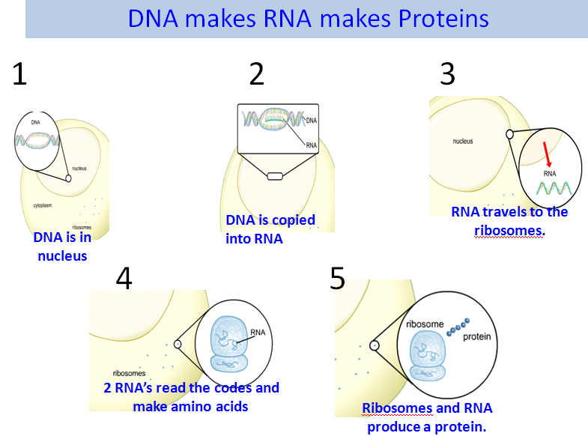  They Might Be Giants Cells: What is that “twisted ladder”?  http://www.youtube.com/watch_popup?v=ZK6YP1Smbxk&vq=medium  DNA Transcription 1:53  http://www.youtube.com/watch?v=5MfSYnItYvg | ________ is the genetic material for all living things on earth.  Proteins are the workers of your body and are made up of a sequence of amino acids.  The instructions in the DNA are transported from the ______________________ to the ribosomes in the cytoplasm by ______________.  The instructions are used to assemble the cell’s ____________________at the ribosomes.  The sequence of DNA determines the sequence of building blocks in the proteins.  The genetic information in the cell flows from  ________ to ___________ to _____________.
Essential Questions  OLS Lesson 7: Plant and Animal Cells In this lesson, students will identify structures that differentiate plant and animal cells | Main Concepts
What structures and functions differentiate plant and animal cells? | - One of the most important differences between plant cells and animal cells is the way they obtain energy.  - Plant cells make their own food through __________________.  Looking at the cell models below, draw an arrow to the organelles found in both cell types.  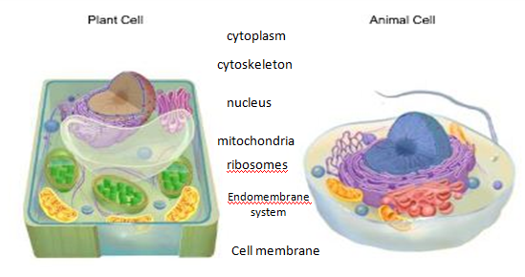  List the structures found in animal cells but not in plant cells  List the structures found  in plant cells but not in animal cells:  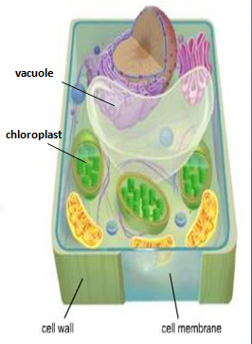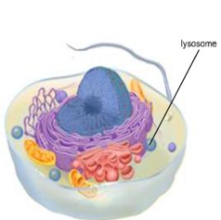  Plant cells have:  Animal cells have:  - __________  - __________  - __________  - __________  - __________

OLS Lesson 8 and 9: Cells and Energy/Diffusion and Osmosis Students will learn how energy is converted and released in plant and animal cells through the process of cellular respiration (in both) and photosynthesis (in plants)
Essential Questions | Main Concepts
Words to know:  Mitochondria  Cellular Respiration  Photosynthesis  Osmosis  Diffusion  Concentration  How do cells meet the challenge of obtaining and using energy?  What role does the mitochondria and chloroplasts have in converting and releasing stored energy in cells?  What role does the cell membrane play in the movement of molecules entering and leaving the cell?  Through which processes does the cell membrane regulate what goes into and out of the cell?  Inner Life of a Cell: http://www.youtube.com/watch_popup?v=wJyUtbn0O5Y&vq=medium  Brainpop: Photosynthesis and respiration: http://glencoe.mcgraw-hill.com/sites/dl/free/0078600472/164155/00053412.html  Diffusion and osmosis interactive: http://www.bbc.co.uk/schools/gcsebitesize/science/add_ocr_gateway/green_world/diffusionact.shtml  Diffusion: The overall movement of molecules from a region of higher concentration  to a region of lower concentration between the two regions  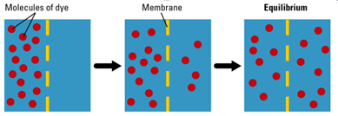 | Cells in Living things need energy to  _____________________________________  Cellular Respiration:  - Takes place in the _____________of both animal and plant cells  - The products of cellular respiration are ____________ _______________ and _____________________  - Some energy released is as ATP which is used to carry on other activities, such as the building and repairing of cells  Glucose + Oxygen = Carbon Dioxide + Water + ATP  Photosynthesis:  - Takes place in the __________ of plant cells, converting light energy into chemical energy  - Product of photosynthesis are ________ and ________  Sunlight + CO₂ ₊ Water = Glucose and Oxygen  The _____________ ___________ controls what substances pass in and out of the cell.  Plant and animal cells use the process of  _______________ and ____________________ in regulating and transporting substances in and out of the cell  The process of diffusion is the movement of atoms and molecules from an area of ________ concentration to an area of __________ concentration and is important in maintaining HOMEOSTASIS.  The movement of water across the cell membrane is called _______________________.

OLS Lesson 10 and 11: Cell Division and Mitosis
Students will explore the process of mitosis and how cells divide and grow. The importance of Cell Division: makes it possible for organisms to grow larger, allows organisms to repair injured tissue, and organisms also reproduce through cell division processes.
Essential Questions | Main Concepts
Words to know:  Cell cycle  Chromosomes  Cytokinesis  Meiosis  Mitosis  Anaphase  Centromere  Chromatids  Metaphase  Prophase  Spindle  telophase  What is the purpose and process of cell division?  Stages of the cell cycle:  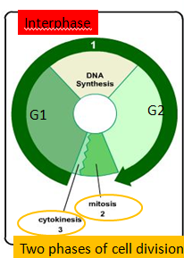  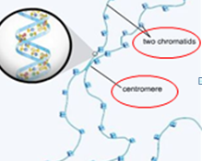  Fill in-------  Cell Division Music videos:  https://www.youtube.com/watch?v=BTicXXxzQA4&playnext=1&list=PL6EBC94D555A66673&feature=results_video  Cell Division Video from K12  http://k12.http.internapcdn.net/k12_vitalstream_com/CURRICULUM/375392/CURRENT_RELEASE/MS2_LIF_02_11_VID_Cell_Mitosis.html | The cell theory states that all new cells come from other cells.  Multicellular organisms increase the number of their cells through __________ ______________________.  Why is cell division important?  The genetic material of a cell is found in structures located in the __________________ called _______________________.  Why must a cell copy its chromosomes before it can go through mitosis? _____________________________________________  _____________________________________________________  - Cell that divides is called a _________ ____________.  - The two new cells are called _________ __________.  - In ________, each daughter cell receives a complete copy of the parent cell’s genetic material.  - The _______ ____________ is the sequence of growth and division of a cell.  - Before mitosis, the parent cell grows and makes a copy of the ______________ _______________in the nucleus.  - During mitosis, the genetic material is divided between the daughter cells.  - Cytokinesis is the part of the cell cycle when the _________________ of the parent cell is divided between the daughter cells.  Chromatids-the two copies of a duplicated chromosome that will eventually end up in separate cells  Centromere- the place where two sister chromatids join in a chromosome before it divides  Prophase:  Metaphase:  Anaphase:  Telophase:
