UNIT 6: Adaptation and Change
Vocabulary:
Word | Parts/meaning of word, if any | Definition | Picture example if any
Trait |  | A characteristic or something about an organism.
Adaptation | Adaptation | Something about an organism that helps it to survive in its environment.
Structural Adaptation | Structural  Adaptation | A physical body part of an organism that helps it to survive.
Behavioral Adaptation | Behavioral  Adaptation | An action or something an organism does to survive in its environment.
Innate Behavior |  | A behavior that is built into an organism since birth (genetic)
Learned Behavior | Learned Behavior | A behavior that an organism develops, or picks up during its life
Endangered

Extinct

Succession

Carrying Capacity

Exponential Growth

Overpopulation

OLS Lesson 1: Change Over Time
Essential Questions | Main Concepts
- What are traits?  - Why have humans bred different types of dogs and horses?  - How can the environment affect the traits of a species?  - How have the traits of sparrows changed over time?  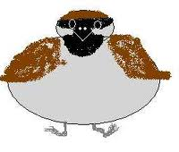 | A trait is _______________________________________  ______________________________________________  List 5 examples of traits  1.__________________________  2.__________________________  3.__________________________  4.__________________________  5.__________________________  To produce different breeds with _________________  (or helpful) traits to people.  What Traits are favorable?  Dogs  Horses  Vegetables  Chickens  Add different environmental changes  House Sparrows were brought to North America in the 1850’s. Over time, their body size has changed.  Sparrows living in the northern part of the continent developed __________________ to survive the colder temperature.  Sparrows in the south developed _________________ to deal with the warmer environment.  The trait of body sized changed because ____________________________________________

OLS Lesson 2: Structural Adaptations
Essential Questions | Main Concepts

- What is an adaptation?  - What is a Structural Adaptation?  - Organisms have structural adaptations for  -getting energy  -maintaining structure and  -getting food. | An adaptation is ______________________________  ____________________________________________.  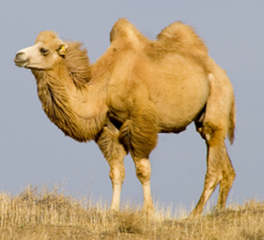  http://www.youtube.com/watch?v=sJH-01WLEg0  List 5 Adaptations of Camels  - ____________________________________  - ____________________________________  - ____________________________________  - ____________________________________  - ____________________________________  A physical ____________ part that helps an organism to survive in its ___________________.  Choose any organism- __________________________.  List 1 structural adaptation it has for each  Challenge of Life Adaptation  Getting Energy-  Maintaining- Structure  Reproducing-

OLS Lesson 3: Behavioral Adaptations
Essential Questions | Main Concepts
- What is a behavioral adaptation?  - What are some behavioral adaptations of  organisms?  - How is Learned Behavior different than Innate Behavior?  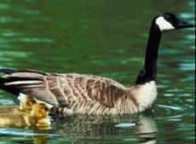  Baby geese learn what their mother looks like and follow her around. This helps them stay together and protects them from predators.  - CHECK THE BOX FOR THE CORRECT TYPE OF ADAPTATION | Behavioral adaptaion- the way an organism ________ or something it does to survive in its environment  Some spend the winter months in a sleeplike state called _______________________.  Some organisms ______________to warmer places during cold months to find food and shelter.  Learned behavior is determined by past _________________, often by observing others.  Innate behavior is _______________ or built into an organism’s body.  Adaptation Structural Behavioral  The THORNS of a rose bush keep animals from eating it.  The COLORFUL SKIN of a poison dart from warn its predators that its toxic.  A lizard keeps warm by sunning itself on a rock.  lizard keeps warm by sunning itself on a rock.  A turtle’s hard shell protects it from predators.  A mother lion teaches her young to hunt.

OLS Lesson 4: Extinct or Endangered
Essential Questions | Main Concepts
- What is an Endangered Species?  - What is an Extinct Species?  - Why has the Giant Panda become an Endangered Species?  - Why do species go endangered or extinct? | - A species in danger of going ________________.  - A species that____________________________.  Giant Panda-  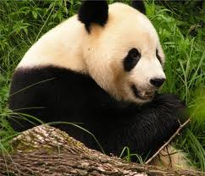  Specialized Diet- 99% of a Giant Pandas food is ____________________.  Adaptations for eating Bamboo  1.__________________________  2.__________________________  3.__________________________  Habitat Loss- The Pandas Bamboo forests are disappearing because of ______________________________________________  Add something more  About a change envi and mismatch of adap

OLS Lesson 5: Changes in Ecosystems
Essential Questions | Main Concepts
- What are some changes that can affect an ecosystem?  There can be changes to the BIOTIC and ABIOTIC parts of the ecosystem.  - How can a tsunami affect an Ecosystem?  - How can a Tsunami affect an ecosystem? | __________________________- The living things in an ecosystem  Examples of Biotic Changes  - ___________________ of new species  - ___________________of species  __________________________- The nonliving things in an ecosystem  Examples of changes  - __________________  - __________________  - __________________  Tsumani- ______________________________________.  Biotic Changes Abiotic Changes

OLS Lesson 6: Rates of Environmental Change
Essential Questions | Main Concepts
- How can the rate of an environmental change affect an ecosystem  - How did the eruption of Mt. St Helen affect the surrounding ecosystem?  - What is succession?  - Put a check in the box labeling the change as rapid/slow and Biotic/Abiotic | ___________ ____________ - a change that takes less than a day  ___________ _____________ - a change that takes more than one day (sometimes over many years)  What happened to the ecosystem during and right after the eruption?  ______________________________________________  ______________________________________________  How did the ecosystem change in the years after the eruption?  ______________________________________________  ______________________________________________  Succession- ___________________________________  ______________________________________________  Change Rate- (rapid or slow)? Biotic or Abiotic?  Regrowth after a volcanic eruption  Flooding  Seasonal Change  Global Warming  Succession  Tree Falling

OLS Lesson 7: Building a Dam
Essential Questions | Main Concepts
- What is a dam?  - How does a human built dam affect the ecosystem?  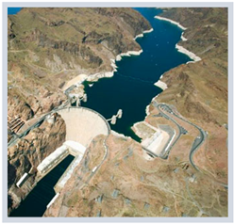  - What are 5 reasons why humans build dams? | Any structure that blocks (or retains) the flow of ______________.  Two organisms that build dams are ____________ and ______________.  How does a human dam affect the ecosystem downstream?  _________________________________________________  _________________________________________________  How can a human dam affect the ecosystem upstream?  _________________________________________________  _________________________________________________  - _______________________________________  - _______________________________________  - _______________________________________  - _______________________________________  - _______________________________________

OLS Lesson 9: Population Changes
Essential Questions | Main Concepts
- How do population changes affect an ecosystem?  - Why was the rabbit population able to grow so large?  - What is Exponential Growth?  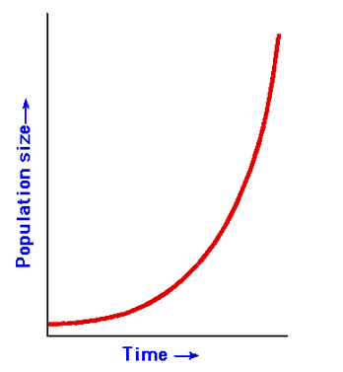  - What is over population?  - How did the exponential growth of Australia’s rabbit population affect the ecosystem?  - What happens when a species is taken out of an ecosystem? | In 1859 a man named Thomas Austin released 24 rabbits in Australia. In six years, those rabbits had reproduced and multiplied to ________________________!  When a species population _________________ without limitation.  When a species population size _________________ the carrying capacity of the environment.  BIOTIC CHANGES ABIOTIC CHANGES

OLS Lesson 10: The Human Factor
Essential Questions | Main Concepts
- How has the human population on earth increased in the past 40 years?  - How do humans change their environment? | Between 1960 and 2000 the human population has gone from ______ to _______ billion.  Human Action Why? Effects on the Environment  Burning Fossil Fuels -  Farming-  Deforestation  Habitat Loss  Something else with this lesson

